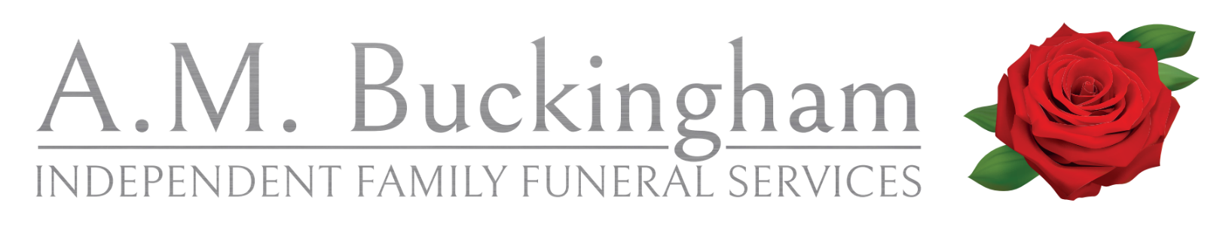
Prices as of 1st April 2026
TRADITIONAL FUNERAL £3100.00
Our Professional Fees £1270.00
Collection and Care of the Deceased £300.00
Preparation and Chapel of Rest £200.00
Standard Oak Effect Coffin £450.00
Hearse and Bearers £300.00
One 7-seater Limousine £300.00
Celebrant £280.00
OTHER FEES APPLY

STANDARD FUNERAL £2520.00
Our Professional Fees £1270.00
Collection and Care of the Deceased £300.00
Preparation and Chapel of Rest £200.00
Standard Oak Effect Coffin £450.00
Hearse and Bearers £300.00
OTHER FEES APPLY

SIMPLICITY FUNERAL £2320.00
Our Professional Fees £1270.00
Collection and Care of the Deceased £300.00
Standard Oak Effect Coffin £455.00
Hearse and Bearers £300.00
OTHER FEES APPLY
DIRECT CREMATION £1450.00
ATTENDED DIRECT CREMATION £1750.00
(additional fee for out of hours removal) £300.00
*ADDITIONAL 7-SEATER LIMOUSINES £300.00

DISBURSEMENTS
Celebrant Fee £280.00
Minister Fee from £450.00
Service Sheets-up to 16 pages with 5 photographs £3.95
Visual Tribute with 25 photographs £100.00
Additional 25 photographs £35.00
(Each Additional photograph) £3.50
Static Image (1st) FREE
Personalised Canvas Experience (Gedling) Prices on request
Additional Static Image £30.00
Webcast £85.00
Permanent Download £85.00
Newspaper Announcement POA
Online funerals notice FREE
Floral Tributes Starting at £75.00

Professional Fees & Disbursements

Professional fees are the charges under the control of the Funeral Director.
These include Funeral Directors’ attendance to all arrangements, completion and delivery of necessary documentation, telephone calls, home visits and personal supervision of the funeral, the provision of a hearse, and a coffin suitable for either cremation or burial.
The conveyance of the deceased to our premises, full preparation, hygienic treatment and care of the deceased.

CREMATORIUM FEES 2026
Bramcote 09.00 only £800.00
Adult full service £1050.00
Rushcliffe Oaks 09.30 only £895.00
Adult full service £1095.00
Wilford Hill £911.00
Gedling 09.30 full service £975.00
10.30 full service £1050.00
11.30-14.30 full service £1275.00
15.30 full service £1175.00

HOLLYGATE MEMORIAL WOODLANDS 2026
Single Burial Plot £1000.00
Single Ashes Plot £200.00
Digging of the Plot £65.00
Interment £180.00
Grave Preparation £450.00
Plaque and Post £300.00
Hollygate Tree £300.00
Bench and placement £1160.00
Bench, Plaque and placement £1510.00

Professional Fees & Disbursements

Disbursements are the third-party charges paid out by the Funeral Director on behalf of the family while arranging the funeral. These prices are out of the control of the funeral director. Examples of these are:

Cemetery fees Obituaries / acknowledgments
Flowers Urns
Catering Keepsakes

MEMORIAL RANGE Prices as of October 2026
Scatter tubes –
All designs Hand crafted from renewable materials, Earth biodegradable & TSA Compliant.
Large (adult) - 4 litres (37cmx13cm) £35.00
Medium - 2 litres (25cmx11cm) £30.00
Small (Infant) - 0.7 litres (22.5cmx7.5cm) £25.00
Small - 0.42 litres (13.5cmx7.5cm) £20.00
Keepsake - 0.06 litres (9cmx3.5cm) £15.00
Ashes caskets-
Solid wood caskets Personalisation is available at extra cost
Exeter – Solid Oak casket varnished. Light Oak £80.00
Exeter- Medium Oak & Dark Oak £85.00
Brentwood- Double ashes casket in light Oak £115.00
Gloucester- Medium Oak £96.00
Chelmsford - Light Oak £81.00
Durham - Available in light Mahogany & light Oak £109.00
1.5 L capacity
Carlisle - Available in dark Mahogany & medium Oak £105.00
Hereford - Light Oak £96.00
Oxford - Light Oak £96.00

